- \Operation\Carton erection\Carton erection system (page 1 of 2)
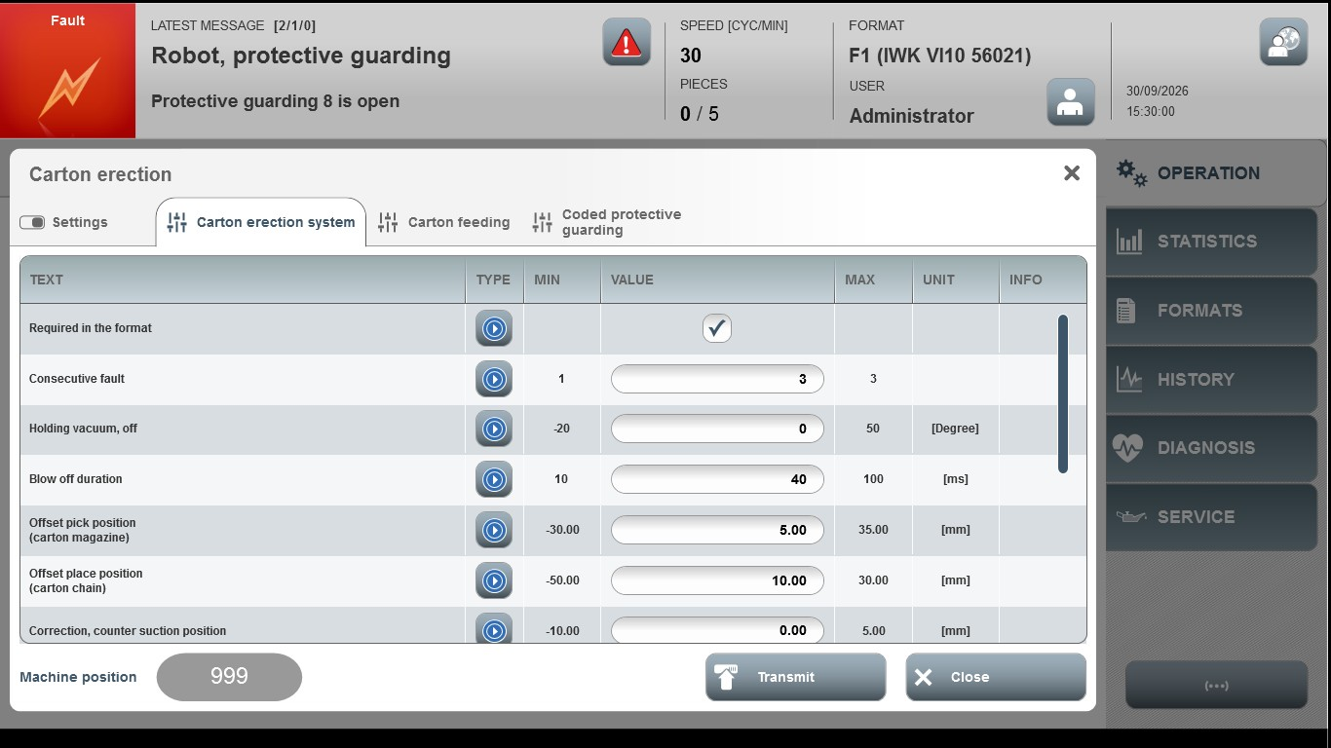
Acceptance criterion | Limits | Pass / Fail: Dev-No. | Date | Initials
Screen matches screenshot | N / A
Consecutive fault | 1…3
Holding vacuum, off | -20…50
Blow off duration | 10…100
Offset pick position (carton magazine) | -30.00...35.00
Offset place positio (carton chain) | -50.00...30.00
Correction, counter suction position | -10.00…5.00

- \Operation\Carton erection\Carton erection system (page 2 of 2)
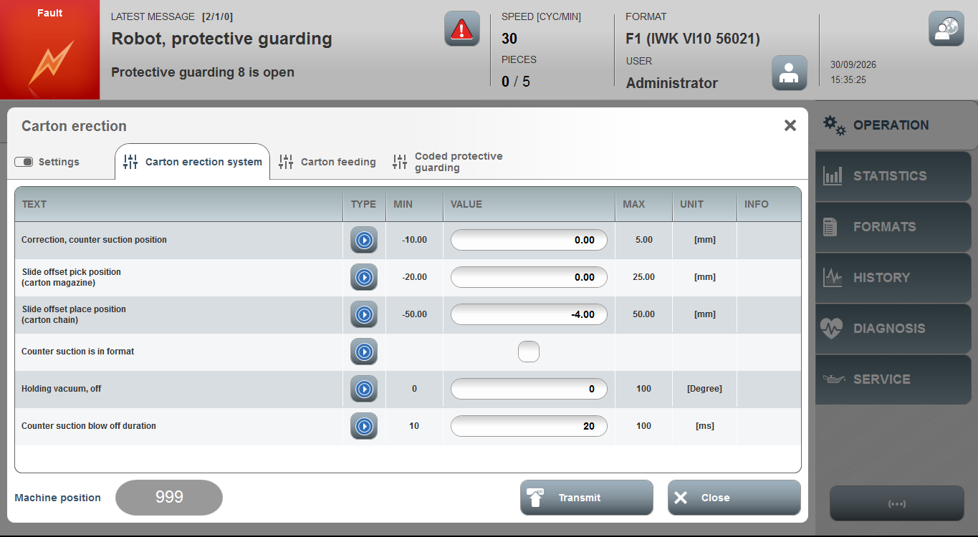
Acceptance criterion | Limits | Pass / Fail: Dev-No. | Date | Initials
Screen matches screenshot | N / A
Slide Offset Place Position (Carton Chain) | -10.00...5.00
Slide Offset Pick Position (Carton magazine) | -20.00...25.00
Slide Offset Place Position (Carton Chain) | -50.00...50.00
Holding vacuum, of | 0…100
Counter suction blow off duration | 10…100

